

ALABAMA BOARD OF NURSING

ANALYSIS OF 2023 ABN LICENSEE SURVEY

Report Date

November 17, 2023

Table of Contents Page #

1.0 EXECUTIVE SUMMARY 3
1.1 Background 3
1.2 Summary of Findings 3
1.3 Recommendations 5
2.0 DETAILED FINDINGS 5
2.1 Samples 5
2.2 Survey Participation 5
2.3 Student Nurse Apprentice, Medication Assistant, Certified and Nursing Student/Graduate Aide 6
2.4 ABN Website 6
2.4.1 Website Access 6
2.4.2 Resources 7
2.4.3 My Profile Menu Options 8
2.5 Communications/Interactions with the ABN 8
2.6 Survey Trends 9
3.0 LIMITATIONS 10
4.0 NURSING IMPLICATIONS 10
5.0 APPENDICES 11
5.1 Appendix A: 2023 ABN Licensee Survey 11
5.2 Appendix B: 2023 ABN Licensee Survey Listserv Invitation 14

1.0 EXECUTIVE SUMMARY

  - Background

The Alabama Board of Nursing (ABN) conducted voluntary licensee surveys in 2017, 2019, 2021 and 2023.

Historically, the surveys focused on:

- participants’ license types and/or advanced practice approvals;
- licensees’ knowledge related to the purpose of the ABN and, when applicable, changes to the Nurse Practice Act;
- accessibility, utilization and quality of ABN resources; and/or
- when applicable, nursing issues related to changes in the healthcare climate.

The 2017 and 2019 survey questions were exactly the same and allowed free-text responses. The 2021 survey included questions specific to the COVID-19 pandemic and the Nurse Licensure Compact implemented in 2020, and did not allow free-text responses.

The 2023 survey included an assessment of licensees’ knowledge of and employers’ utilization of ABN supplemental nursing roles.

- The 2023 ABN Licensee Survey was conducted August 7-21, 2023.
- Data was collected using the ABN’s SurveyMonkey subscription.
- The survey consisted of ten or eleven questions. Free-text responses were not permitted (see Appendix A).
- The ABN’s Email Listserv was used to invite all Alabama licensed nurses to participate in the survey on August 7, 2023 (see Appendix B). A reminder email was sent one week later, on August 14, 2023.

  - Summary of Findings

- Participation in the biennial Licensee Survey declined each survey year (see table below).

- Just over one-third of participants reported not working with, or even having knowledge of, Nursing Students/Graduate Aides, Student Nurse Apprentices (SNAs) or Medication Assistants, Certified (MACs) supplemental nursing roles.
  - Of those who did not work with or have knowledge of these supplemental nursing roles, 29% reported being employed in an acute care or long-term acute care hospital, 6% were employed in long-term care/nursing home, and the remaining 65% were employed in some of facility type/setting.
  - Participants were permitted to choose more than one selection, but the responses were transformed by Excel to traditional percentages reported in the chart below.

- 53% of participants accessed the ABN website 1-2 times per year. License renewal, continuing education and My Profile were the top three reasons for accessing the ABN website. Detailed ratings for My Profile menu options are shown in the table below.

- ABN communication types were highly rated as good or excellent as shown in the chart below.

- Overall, when compared to participants’ interactions with other state or local agencies, 91% of nurses rated the quality of ABN interactions as Excellent or Good.

  - Recommendations

- Consider short, focused surveys to assess specific topics (e.g., CE topics of interest to nurses, website usability, utilization of new non-nursing roles, quality of CE offerings, quality of communications, issues with CE courses/uploading certificates/ transcripts, issues identified in the survey as needing improvement, etc.) and distribute the focused surveys at periodic intervals.
- Pilot the surveys among ABN staff before distribution to improve obtaining quantifiably measurable responses.
- Consider alternative delivery methods (e.g., social media).
- Revise and shorten the email invitation.
- Place License Lookup option in a prominent place on the new website design.
- Add a link in the next newsletter so nurses can access the findings from this analysis.
- Revise the Leadership Institute enrollment and participation processes.
- Educate nurses and employers about Nursing Students/Graduate Aides, SNAs and/or MACs supplemental nursing roles and the impact these roles can have on the nursing workforce and patient care.
- Create a JITT video when new regulations are implemented and identify the video as new.

  - DETAILED FINDINGS

  - Samples

- An invitation to participate in the survey was emailed to 97,627 Alabama licensed LPNs, RNs, and APRNs. The email was opened by 61,112 (63%) Alabama licensed nurses.
- The invitation was also emailed to 1,037 APRNs practicing in Alabama under a multistate licensure privilege (MSP). It was opened by 773 (75%) MSP APRNs.
- The total sample eligible to participate was 98,664.
- The potential sample, those who opened the invitation email, was 61,885 (63% of the total eligible and invited to participate).
- The sample of nurses who participated in the survey was 11,091 (n=11,091), 11% of the nursing population in Alabama.

  - Survey Participation

The following nurses participated in the survey.

- 81.5% (9,037) were RNs.
- 12.4% (1,375) of RNs were APRNs.
  - 80% (1,094) of APRNs were CRNPs and CNMs.

- 18.5% (2,054) were LPNs.

Participants answered 95% to 100% of the survey questions.

- 100% answered Question 1 (Please identify your license type/level of practice).
- Question 3 (If your employing facility does not use the SNA, MAC, or Nursing Student/Graduate Aide role, in what facility type are you employed?) was conditional upon responses to Question 2. Since this question was essentially an expansion of Question 2, it was excluded from the calculation of the percentage of questions answered.
- All participants had the opportunity to provide a response to Question 10 (When comparing your interactions with the ABN to other state or local agencies, how would you rate the quality of services you received from ABN?). This question received the second lowest number of responses (10,111).

  - Student Nurse Apprentice, Medication Assistant, Certified and Nursing Student/Graduate Aide

11,037 participants responded to Question 2: Have you worked with, or does your facility employ, any of the following roles? (Select all that apply.) The roles included: SNAs, MACs and Nursing Students/Graduate Aides.

- More nurses reported working with or in a facility employing Nursing Students/ Graduate Aides than the other two roles.
- 4,015 reported working with or in a facility employing Nursing Students/Graduate Aids.
- 2,336 reported working with or in a facility employing SNAs.
- 2,363 reported working with or in a facility employing MACs.

- 3,930 reported not working with any of the roles.

- 1,466 reported no knowledge of any of the roles.

4,745 participants responded to Question 3: If your employing facility does not use the SNA, MAC, or Nursing Student/Graduate Aide role, in what facility type are you employed?
- 29% (1,374) were employed in an acute care hospital (ACH) or long-term acute care hospital (LTAC).
- 6% (288) were employed in a long-term care (LTC) facility or nursing home (NH).
- 65% (3,083) were employed in a facility other than an ACH, LTACH, LTC facility or NH.

  - ABN Website

2.4.1 Website Access

10,496 participants responded to Question 4: Approximately how often do you access the ABN website?
- 53% (5,512) accessed the site 1-2 times per year or only when looking for something in particular.
- 23% (2,306) accessed the site quarterly.
- 15% (1,527) accessed the site only at renewal.
- 11% (1,151) accessed the site at least once a month.

10,504 participants responded to Question 5: When you visit the ABN website, what information do you usually seek out? (Select all that apply.) The table below reflects the responses.

Reasons for Accessing ABN Website Ranked from Most to Least Frequent
Options | Percentage of Participants
- License renewal | 79.82%
- Continuing education | 79.67%
- My Profile | 71.02%
- License Lookup | 42.70%
- Practice standards (Chapter 6 & 7 of the rules) | 20.25%
- The rules (ABN Administrative Code) | 19.85%
- Compact information | 17.45%
- Advanced practice rules (Chapter 5 & 9 of the rules) | 10.10%
- Advanced practice applications (i.e., Add/New Collaboration) | 5.38%
- Discipline/VDAP/Monitoring information | 3.85%
- Other | 2.58%

2.4.2 Resources

- 10,489 participants responded to Question 6: Have you accessed ABN's Online CE Course Catalog?
  - 69% (7,195) accessed the catalog (see chart below).
  - 20% (2,182) had not accessed the catalog.
  - 11% (1,112) reported not knowing about the catalog.

- 10,476 participants responded to Question 7: Have you enrolled in ABN's Leadership Institute?
  - 3% (355) were enrolled (see chart below).
  - 68% (7,111) were not enrolled.
  - 29% (3,010) reported not knowing about the institute.

- 10,478 participants responded to Question 8: Have you watched any of ABN's Just in Time Training (JITT) videos?
  - 12% (1,303) viewed the videos (see chart below).
  - 50% (5,181) had not viewed the videos.
  - 38% (3,994) reported not knowing about the videos.

2.4.3 My Profile Menu Options

10,129 participants responded to Question 11: Please rate the following My Profile menu options. Participants reporting not applicable (N/A) or No experience with My Profile menu options were excluded from the analysis. The results are shown in the 2023 Licensees Survey Ratings: My Profile Menu Options table.

- 7,274 rated the Name change/uploading document option.
  - 93% (6,797) rated this option as Good to Excellent.
  - 7% (477) reported this option needed improvement.

- 9,235 rated the Adding CE courses/uploading certificate or transcript option.
  - 84% (7,746) rated this option as Good to Excellent.
  - 16% (1,488) reported this option needed improvement.

- 5,520 rated the Applications option.
  - 90% (4,993) rated this option as Good to Excellent.
  - 10% (527) reported this option needed improvement.

- 5,543 rated the Instructional videos option.
  - 92% (5,116) rated this option as Good to Excellent.
  - 8% (427) reported this option needed improvement.

- 8,145 rated the ABN CE transcript option.
  - 91% (7,433) rated this option as Good to Excellent.
  - 9% (712) reported this option needed improvement.

2.5 Communications/Interactions with the ABN

10,127 participants responded to Question 9: Please rate the following communications that you have had with the ABN within the last 24 months. Participants reporting N/A or No experience with ABN communications were excluded from the analysis. The results are shown in the 2023 Ratings ABN Communication Types table.

- 7,175 rated email communications.
  - 94% (6,731) rated email communication as Good to Excellent.
  - 6% (444) reported email communication needed improvement.
- 2,527 rated phone communications.
  - 84% (2,123) rated phone communication as Good to Excellent.
  - 16% (404) reported phone communication needed improvement.

- 1,389 rated communications via online chat.
  - 86% (1,197) rated communications via online chat as Good to Excellent.
  - 14% (192) reported communication via online chat needed improvement.

- 1,678 rated communications via social media.
  - 86% (1,451) rated communications via social media as Good to Excellent.
  - 14% (227) reported communications via social media needed improvement.
- 2,312 rated letter communications.
  - 90% (2,090) rated letter communications as Good to Excellent.
  - 10% (222) reported letter communications needed improvement.

- 1,303 rated communications via live presentation.
  - 90% (1,170) rated communications via live presentation as Good to Excellent.
  - 10% (133) reported communications via live presentation needed improvement.

10,111 participants responded to Question 10: When comparing your interactions with the ABN to other state or local agencies, how would you rate the quality of services you received from ABN?

- 61% (6,178) participants reported interactions with the ABN.
  - 39% (2,394) rated the quality of ABN interactions as excellent.
  - 52% (3,237) rated the quality of ABN interactions as good
  - 9% (547) reported the quality of ABN interactions need improvement.

- 39% (3,933) reported not applicable or no experience with ABN interactions.

2.6 Survey Trends

Although specific wording of some survey questions did not match verbatim, when possible, similar topics included on the 2017, 2019, 2021, and 2023 surveys were compared.

- Survey participation declined each survey year (see Licensee Survey Participants 2017-2023).

- Utilization of ABN CE offerings was highest in 2023
  - In 2023, 80% used ABN CE offerings.
  - In 2021, 58% used ABN CE offerings.
  - In 2019, 59% used ABN CE offerings.
  - In 2017, 68% used ABN CE offerings.

- Positive interactions with the ABN improved. In 2021, this was not assessed.
  - In 2023, 91% reported the quality of interactions with the ABN was Excellent or Good (see 2023 Ratings ABN Communication Types).
  - In 2019, 80% reported positive interactions with the ABN.
  - In 2017, 78% reported positive interactions with the ABN.

- LIMITATIONS

- Surveyor bias may have affected the phrasing and/or formatting of the survey and, consequently, data analysis.
- Participant biases may have impacted the response rate and responses provided.

- NURSING IMPLICATIONS

- Based on the low response rate, nurses may be experiencing survey fatigue which could lead to response bias.
- Nurses and employers may not be aware of Nursing Students/Graduate Aides, SNAs and/or MACs roles and the impact these roles can have on the nursing workforce and patient care.
- Nurses are working on interdisciplinary teams and assisting with training the next generation of nurses. This demonstrates the importance of leadership training and continued robust implementation of activities of the ABN Leadership Institute.

- APPENDICES

5.1 Appendix A: 2023 ABN Licensee Survey

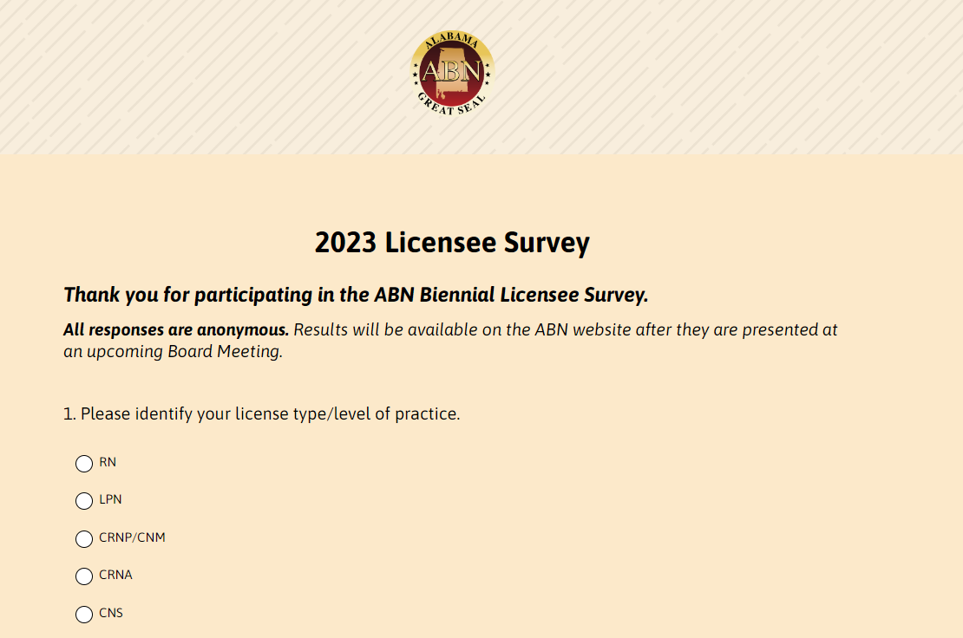
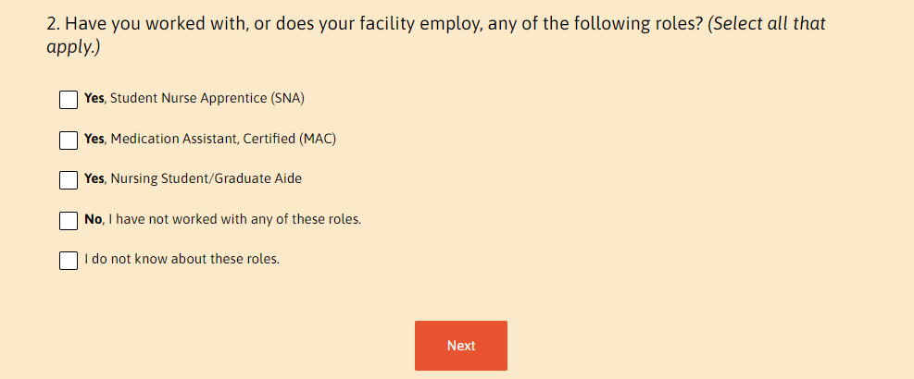
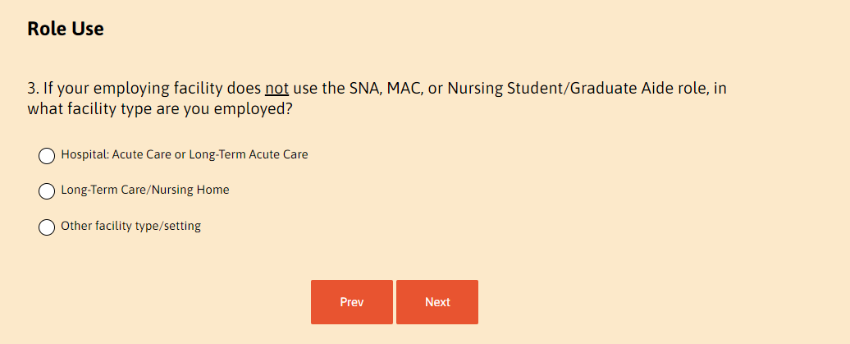
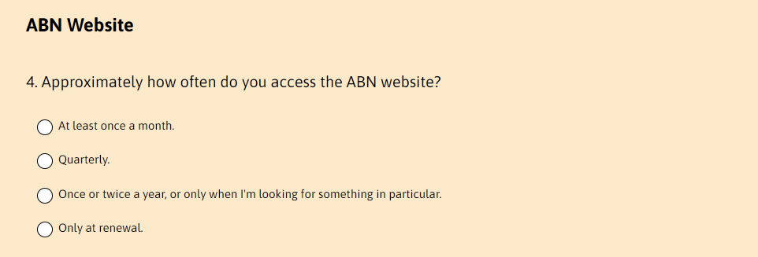
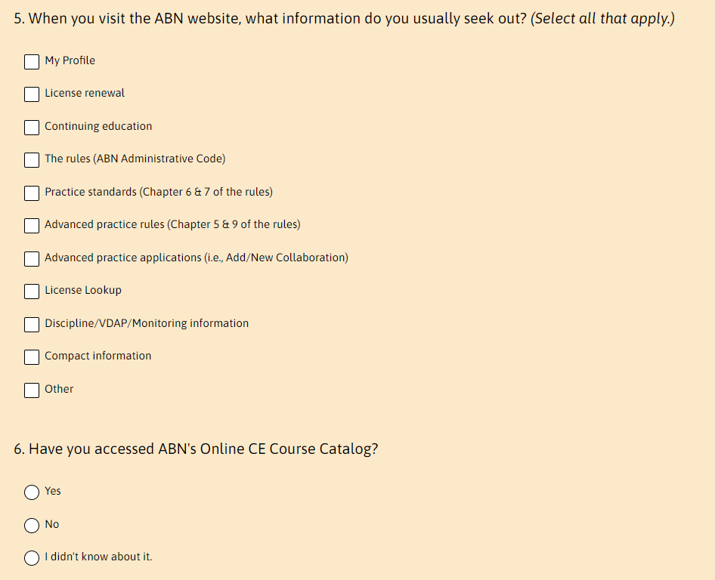
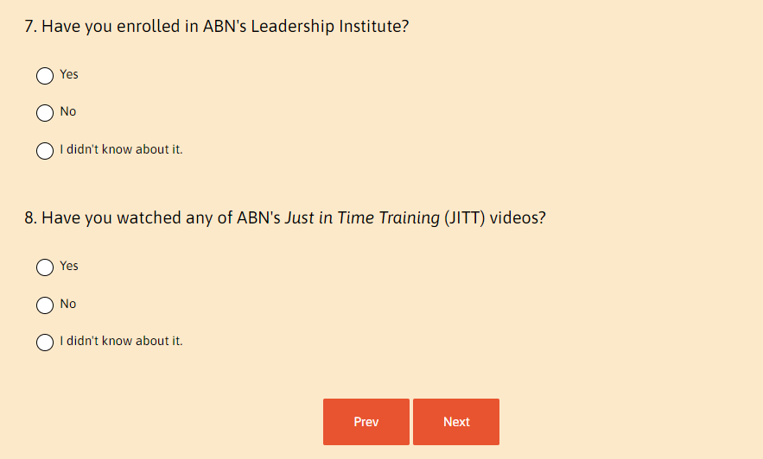
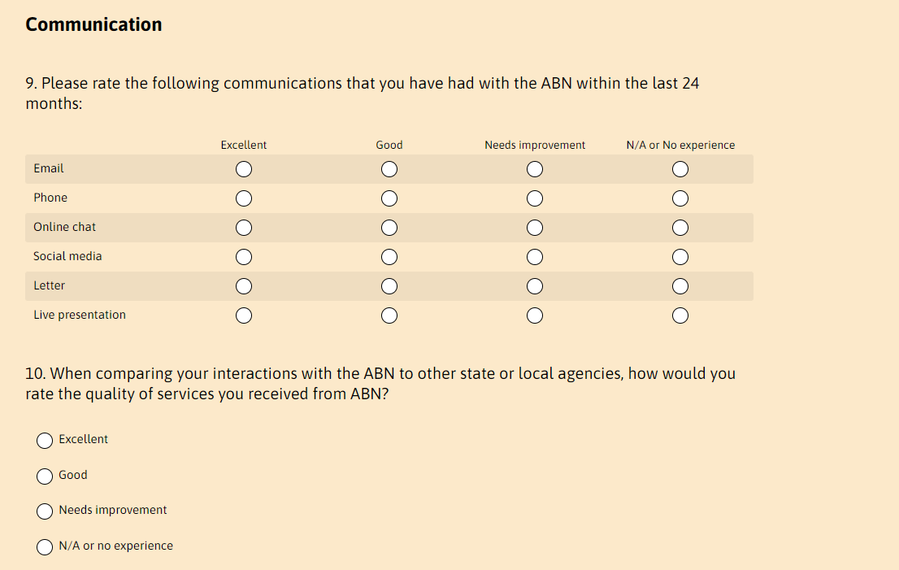
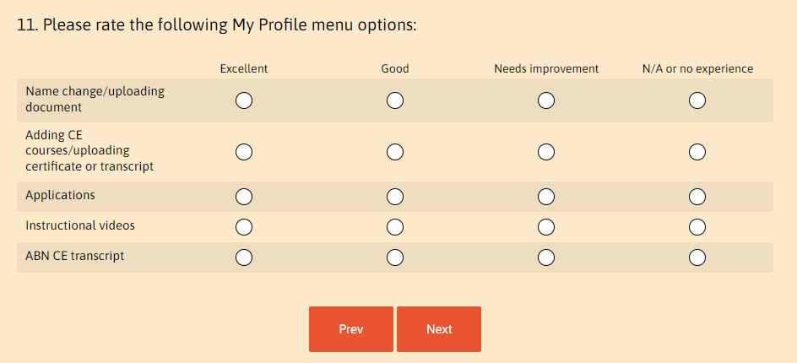

5.2 Appendix B: 2023 ABN Licensee Survey Listserv Invitation

